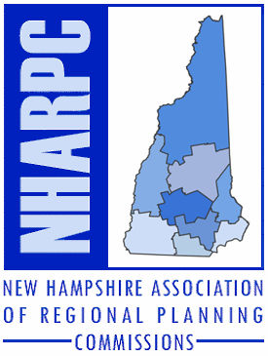
NHARPC Meeting

October 21, 2020

1:00 p.m.

Zoom Meeting Link:
http://bit.ly/Oct21NHARPC29

Call-in Number: 1-646-558-8656

Meeting ID: 821 5871 6466
Passcode: 425970

Agenda

- Call to Order and Introductions

- Minutes of June 18, 2020 and August 25, 2020 Meetings

- Affiliate Conference Support - Follow-up

a. NNECAPA Annual Conference

- NHARPC - NHMA Partnership

a. Town & City Articles and Webinars

V. Legislative Matters

a. Update on Commission to Study Barriers to Increased Density of Land Development (SB 43)

b. 2021 Legislative Session

VI. Other Matters

VII. Next Meeting

VIII. Public Comment

IX. Adjourn

37 Ashuelot Street
Keene, NH 03431
603-357-0557

Central NH Regional
Planning Commission
28 Commercial St. Suite 3
Concord, NH 03301
Telephone: 226-6020

Lakes Region
Planning Commission
103 Main St. Suite 3
Meredith, NH 03253
Telephone: 279-8171

Nashua Regional
Planning Commission
30 Temple St. Suite 310
Nashua, NH 03060
Telephone: 417-6570

North Country Council
161 Main St.
Littleton, NH 03561
Telephone: 444-6303

Rockingham
Planning Commission
156 Water Street
Exeter, NH 03833
Telephone: 778-0885

Southern NH
Planning Commission
438 Dubuque Street
Manchester, NH 03102
Telephone: 669-4664

Southwest Region
Planning Commission
37 Ashuelot Street
Keene, NH 03431
Telephone: 357-0557

Strafford Regional
Planning Commission
150 Wakefield St. Suite 12
Rochester, NH 03867
Telephone: 994-3500

Upper Valley Lake Sunapee
Regional Planning Commission
10 Water St. Suite 225
Lebanon, NH 03766
Telephone: 448-1680

